**Day 28 Home questions**

#1. WAP to display the reverse of a number entered through keyboard.

Code:

#include <stdio.h>

int main()

{

    int i285,rem285,n285,div285;

    printf("Please provide the number you want to be reversed=>");

    scanf("%d",&n285);

    for(i285=1;i285<=n285;n285=n285/10)

    {

        rem285=n285%10;

        printf("%d",rem285);

    }

    return 0;

}

Output:

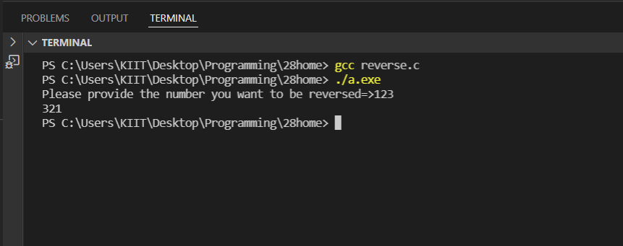



#2. WAP to check whether an integer number is a Armstrong number or not!.

Code:

#include <stdio.h>

#include <math.h>

int main()

{

    int i285,sum285,n285,rem285,globe285,j285,dummy285;

    printf("Please provide a number to check if it is armstrong=>");

    scanf("%d",&n285);

    globe285=n285;

    for(i285=1;i285<=n285;n285=n285/10)

    {

        rem285=n285%10;

        sum285= sum285 + pow(rem285,3);

        if(sum285==globe285)

        {

            dummy285=1;

            printf("yes %d is an armstrong number!\n",globe285);

        }

    }

    if(dummy285!=1)

    {

        printf("%d is not an armstrong number",globe285);

    }

    return 0;

}

Output:

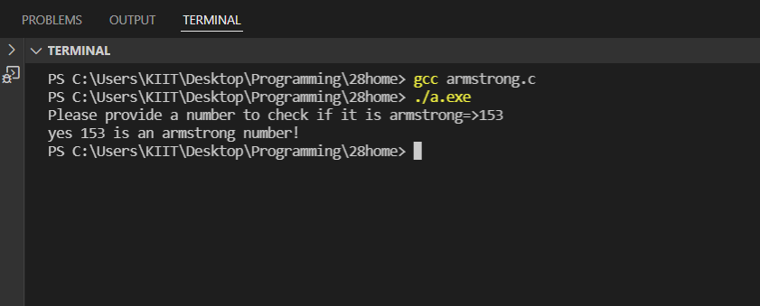

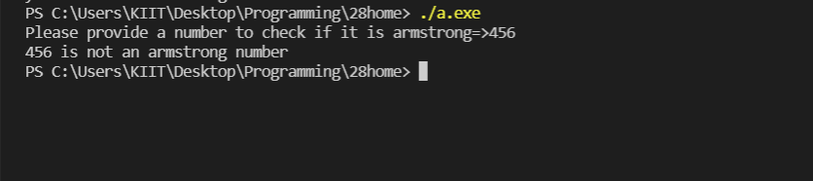

#3. WAP to print the following pattern for n rows. Ex. for n=5 rows

A

B A

C B A

D C B A

E D C B A

Code:

#include<stdio.h>

void main()

{

    int i285,j285,n285;

    printf("\nEnter the number of lines\n");

    scanf("%d",&n285);

    for(i285=1;i285<=n285;i285++)

    {

        for(j285=i285;j285>=1;j285--)

        {

            printf("%c ",(char)(j285+64));

        }

        printf("\n");

    }

}

Output:

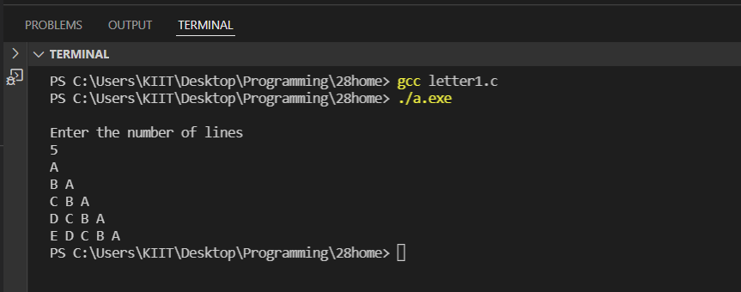

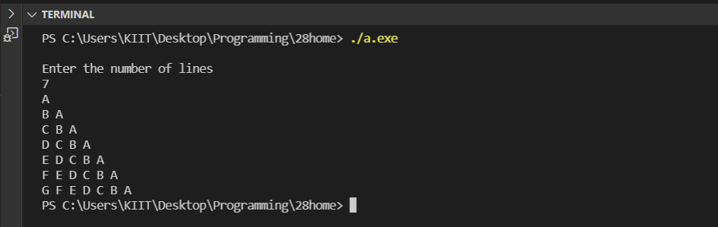

#4. WAP to print the following pattern for n rows. Ex. for n=5 rows

1

2 1

1 2 3

4 3 2 1

1 2 3 4 5

Code:

#include <stdio.h>

int main()

{

int i285, j285, N285;

printf("\nEnter rows: ");

scanf("%d", &N285);

for(i285=1; i285<=N285; i285++)

{

    if(i285 & 1)

    {

        for(j285=1; j285<=i285; j285++)

        {printf("%d ", j285);}

    }

    else

    {

        for(j285=i285; j285>=1; j285--)

        {printf("%d ", j285);}

    }

printf("\n");

}

return 0;

}

Output:

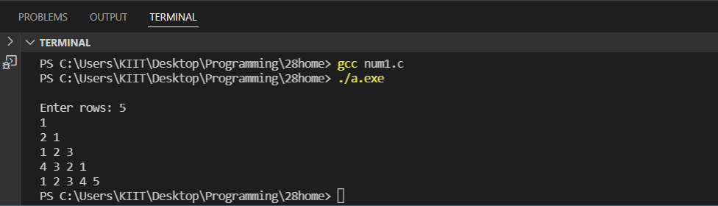

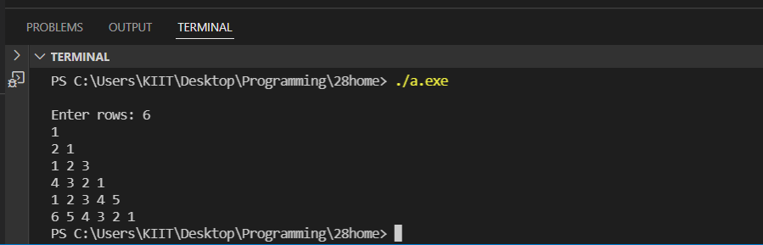

#5. WAP to form reverse pyramid of numbers for a given number. Ex. for

number 4

1 2 3 4 3 2 1

1 2 3 2 1

1 2 1

1